**Daily Scrum or Standup Meeting**

Team name: 5th Element

Scrum Master: Leonardo Craven

Date: November 17, 2021

| **Team Member** | **What did you do since the last scrum?** | **What do you plan to do before the next scrum?** | **What obstacles do you have?** |
| --- | --- | --- | --- |
| Leo | Nothing | Work on company account migration | Midterms |
| Gavin | Researched templates within templates for navigation sidebar | Work on company account migration | None |
| Andrew | Worked on navigation sidebar, home page | Work on navigation sidebar, home page | None |
| Brock | Working on company account migration | Work on company account migration | Figure out how to create user in migration |

# Burndown

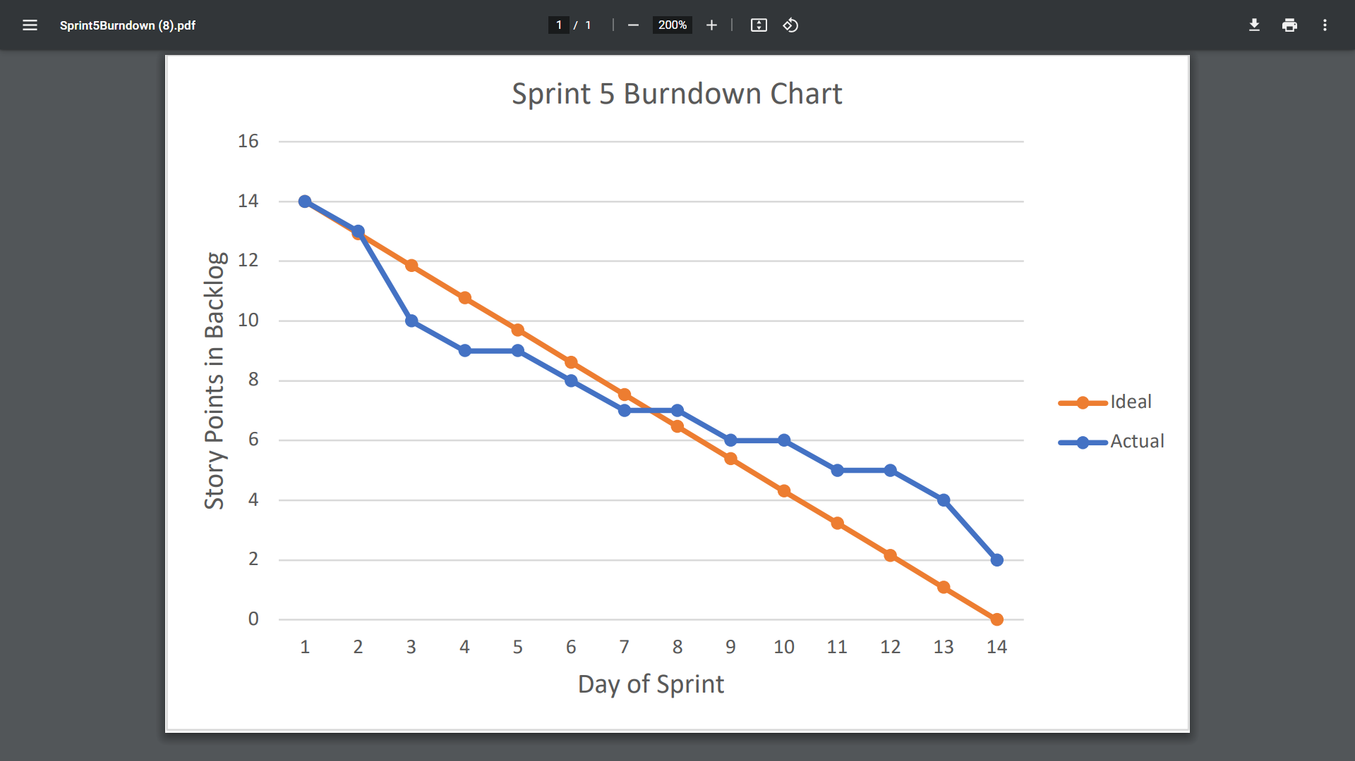

# Screenshot of you project board

